Topology Prelim, September 24, 1992

Problems
- Let $A$ and $B$ be disjoint small round open disks in $S^{2}$ and let $h$ be a homeomorphism from $A$ to $B$. Let $X=S^{2}/∼$ have the quotient topology where $a∼h(a)$ for all $a∈A$.
- 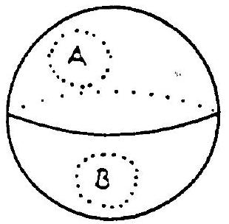
  - Is $X$ Hausdorff?
  - Is $X$ connected?
- Let $X$ be the union of a torus and a disk as shown below. Compute the homology of $X$.
- 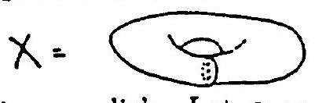
- Let $T$ be a torus minus a small round open disk. Let $α=∂T$ and use covering spaces to show that $[α]≠1∈π_{1}(T,*)$.
- State the homotopy lifting theorem for covering spaces and then use it to compute $π_{1}(S^{1},*)$.
- Let $X$ be an arbitrary subset of $R$. Let $f:X→R$ be proper (this means $f^{-1}$ (compact subset of $R$) = compact subset of $X$). Show that the graph of $f$ is a closed subset of $R^{2}$.
- Let $f:X→X$ be continuous.
  - If $X=S^{1}∨S^{1}$ must $f$ have a fixed point?
  - If $X=I∨I$ (the wedge product of two closed intervals along an interior point of each) must $f$ have a fixed point?
- Let $S^{1}=\left\{\vec{v}∈R^{2}∣|\vec{v}|=1\right\}$. Suppose $f:S^{1}→R^{2}-0$ is continuous and $\vec{v}⋅f(\vec{v})>0$ for all $\vec{v}∈S^{1}$. Prove that $f$ does not extend to a function from $D^{2}$ into $R^{2}-0$.
- Let $A$ be the union of two disjoint circles contained in $R^{3}⊂R^{3}∪\{∞\}=S^{3}$ as indicated. Compute the homology of $R^{3}-A$.

